146 Exmouth Road, Ruislip, London, HA4 0UQ
++447984 249 495
British EU Passport.
Full Driving License + own car.

Rianna Charles
Costumier & Dress Maker

Relevant Skills:
Pattern Cutting, Flat and Stand drafting.
Basic Skills in: Dyeing, Breaking down, Wig Dressing, Millinery and Dancewear.
Domestic and industrial sewing machine and over locker.
Wardrobe maintenance.
Health and Safety trained.
Alterations
Computer literate: Word, Power point & Excel.

Profile:
London based costumier, experienced in wardrobe supervising, dress making, assisting and backstage dressing. Good knowledge of historical, modern and contemporary styles with the drive to recreate with accuracy. Warm and positive character; Ambitious, organised and efficient, with good communication skills. Work well independently or as part of a team.

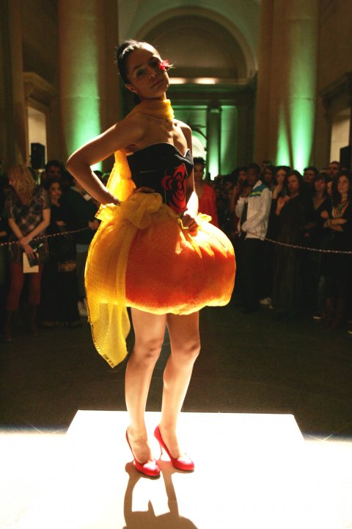
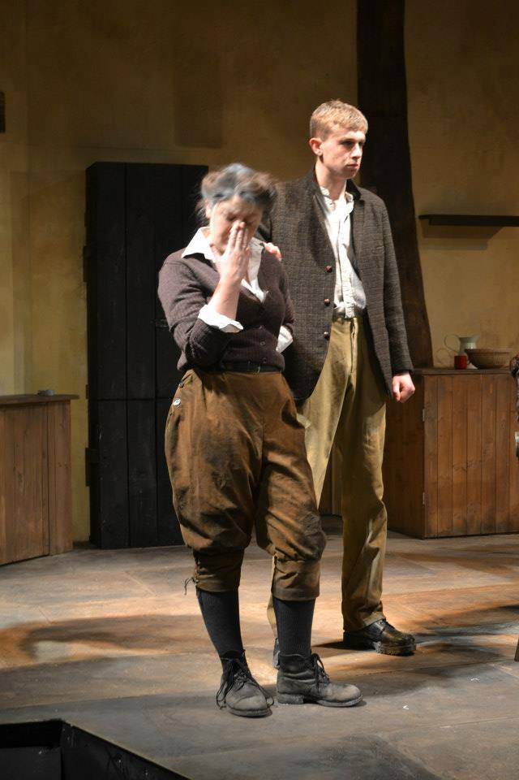
Work Experience: | Employment:
Into The Woods: RBC Productions.  Costume Maker  03.14 | Play worker.  Professional Play worker Practis  18.07.13 - Present
The Supremes tribute act.  Supervisor, Designer, Maker & Director.  01.14 | Moving Venue & Insource LTD.  Hospitality Assistant & Team Leader.  10.10 – Present.
Thursford Christmas Spectacular.  Wardrobe Assistant  20.10.13 - 09.11.13 | John Lewis and Waitrose Partnership.  Hospitality Assistant.  07.11 – 09.12
Thriller Live West End.  Costume Dresser.  04.10.13 | References:
Pornography: RBC Productions.  Costume Assistant/ Dresser.  06.05.13-14 .06.13 | Mr Colin Window. Costume Tutor.  Telephone: 0208 308 2600.  Email:colin.window@bruford.ac.uk
Harvest: RBC Productions.  Costume Assistant/ Dresser  18.02.13 – 26.02.13 | Mrs Ruth Trbojevic. Youth Pastor.  Telephone: 0208 840 7508.  Email:rt@ecc.org.uk
Emergency Exit Arts.
Costume Maker.
07.12
Education

Dates: | Institute: | Qualification:
01.09.11 – 20.06.14 | Rose Bruford College | BA Hons Costume Production
30.08.12 - 30.08.15 | CRB | CRB Checked.
11.07.11 (exp 3 years). | A.B.C First Aid Limited | Emergency First Aid At Work.
06.09.10 – 14.04.11 | London College Of Fashion | Pass - Diploma Foundation In Art & Design
08.09.08 – 27.06.10 | National Open College Network | NOCN Level 1 & 2 in Religious Education.
08.09.08 – 27.06.10 | St. Dominic’s Sixth Form College | 3 A Levels: A* (Art), C (Biology), D (Chemistry)  1 AS level: D (Psychology)
02.09.03 – 13.06.08 | Ellen Wilkinson School For Girls | 11 GCSE’s – A* - B

